**IMPROVING FUEL CONSUMPTION USING ELECTRONIC FUEL INJECTION TECHNOLOGY FOR LOW-POWERED MOTORBIKE ENGINE**

PSD 1 report submitted in partial fulfillment of the

Requirements for the degree of

**Master of Engineering**

**ME (Embedded Systems)**

by

**ADARSH PRABHAKAR**

231039034

**MANIPAL SCHOOL OF INFORMATION SCIENCES**

**(A Constituent unit of MAHE, Manipal)**

**Acknowledgement**

It is great pleasure to thank the people behind the success of this PSD 1 activity. I owe my deepest gratitude to all those who guided, inspired, and helped me to complete this project.

I would like to take this opportunity to express my gratitude and heartiest thanks to my panel members, **Prof. Mr Sathyendranath Malli**, Associate Professor and **Prof. Dr. B V Ravindra** Assistant Professor, Manipal School of Information Sciences for his inspirational support and guidance throughout my project period.

My heartful gratitude to **Dr Keerthana Prasad** Professor & Director Manipal School of Information Sciences for his full support and encouragement during the PSD 1 activity.

I would like to thank all sources mentioned in the references.

**LIST OF TABLES**

|  |  |  |
| --- | --- | --- |
| **Table No** | **Table Title** | **Page No** |
| 1 | Specifications of the Motorbike Engine | 11 |
| 2 | Fuel Injector Specification | 12 |
| 3 | Engine Parameters For EFI System | 19 |

**LIST OF FIGURES**

|  |  |  |
| --- | --- | --- |
| **Table No** | **Figure Title** | **Page No** |
| 1 | Closed-loop Control Concept | 8 |
| 2 | 3D map of volumetric eff. w.r.t. intake manifold pressure and engine speed | 9 |
| 3 | EFI system schematic integrated to motorbike engine | 12 |
| 4 | R-T curve for air and engine temperature sensors | 14 |
| 5 | A/F ratio at different O2S output voltages | 14 |
| 6 | Schematic of ECU input and output connections | 15 |
| 7 | Start fuel factor (fst) w.r.t engine cylinder temperature | 16 |
| 8 | After-start(fas) and warm-up (fw) fuel factors at different engine cylinder temperature | 17 |
| 9 | Temperature based correction factor for ignition output angle | 17 |
| 10 | Battery voltage based correction factor for ignition output angle | 17 |
| 11 | Comparison of fuel consumption for carburetor and EFI engine | 19 |

**Contents**

|  |  |  |  |  |  |  |  |
| --- | --- | --- | --- | --- | --- | --- | --- |
|  | | | | | | Page No | |
| Acknowledgement | | | |  | | i | |
| List of Tables | | | |  | | ii | |
| List of Figures | | | |  | | iii | |
|  | | | | | | | |
| **ABSTRACT** | | | | | | 6 | |
| **Chapter 1** | | | **INTRODUCTION** | | | 6 | |
|  | 1.1 | Introduction | | | 6 | |
|  | 1.2 | Literature review | | | 7 | |
|  | 1.3 | Motivation to do the Seminar Presentation | | | 7 | |
|  | 1.4 | Objective of the work | | | 7 | |
|  | | | | | | | |
| **Chapter 2** | | | **BACKGROUND THEORY** | | |  | |
|  | 2.1 | Introduction | | | 8 | |
|  | 2.2 | Mathematical Background | | | 8 | |
|  | | | | | | | |
| **Chapter 3** | | | **METHODOLOGY** | | |  | |
|  | 3.1 | Schematic Setup | | | 11 | |
|  | 3.2 | Air Induction System | | | 13 | |
|  | 3.3 | Process Control and Calibration Components | | | 15 | |
|  | 3.4 | EFI Performance Parameters | | | 15 | |
|  | 3.5 | EFI Performance Testing Parameters | | | 18 | |
|  | | | | | | | |
| **Chapter 4** | | | **RESULT ANALYSIS** | | |  | |
|  | 4.1 | Results and Discussions | | | 19 | |
|  | | | | | | | |
| **Chapter 5** | | | **CONCLUSIONS & FUTURE SCOPE** | | |  | |
|  | 5.1 | Conclusions | | | 21 | |
|  | 5.2 | Future scope of work | | | 21 | |
|  | | | | | | | |
| **REFERENCES** | | | | | | 23 | |

**Abstract**

**Chapter 1**

**Introduction**

* 1. **Introduction**

Most of the motorbikes in developing countries use carburetor for the metering of fuel with air. However, carbureted vehicles have many drawbacks such as higher fuel consumption, cold start problem, and many hazardous emissions. Electronic Fuel Injection (EFI) is a sophisticated and effective fuel delivery system that is developed to replace carburetor in order to increase fuel efficiency and reduce emissions and it is also a low cost alternative in an effort to reduce fuel costs and air pollution. In this paper, a comprehensive study was performed by replacing carbureted system with a closed-loop EFI system for small 70 cm3 4-stroke gasoline engine and test results were extracted by comparing both systems in terms of fuel consumption and its drivability. The results show that EFI system improves average fuel economy of 13% on most of its speed ranges and it also offers significant fuel saving of 16.4% on loaded condition relative to otherwise equivalent, carbureted baseline vehicles. The reasons for better fuel efficiency are due to the determination of correct fuel quantity for different engine operating conditions by using pulse-width correction factors and by engine maps optimization with respect to engine speed and load. Other benefits related to this system, are improved cold start and drivability.

Small gasoline motorbikes usually in the range of 50 cubic centimeter (cc) to 250cc are widely used in many countries because of the convenience and good fuel economy owing to high power to weight ratio. 26 million motorcycles were registered in year 2001, in which 8% account for Europe while 70% are from Asian countries. A survey of the worldwide motorcycles distributed performed in 2012 ranked Asia first with 78% of the total number of motorcycles, Europe (14%) and Latin America (5%) followed. The reason that motivates most people to choose motorcycle as a mode of transport, especially in developing countries, is the continuous increase in fuel price. As motorbike engines come with small engine capacity, hence, lower fuel consumption. Therefore, vehicle fuel efficiency is of utmost interest to many manufacturing industries and research organizations. In many countries around the world, small motorcycles use carburetor that mechanically controls the mixing of fuel with air. However, this mechanical injection system has many drawbacks such as poor control of Air Fuel (A/F) ratio during sudden acceleration and deceleration, cold start problem, no altitude compensations and high emissions. Accounting to the high usage of motorcycles on the road, this system has been the major contributor to air pollution especially in urban areas of developing countries. The desire for increased fuel economy in conjunction with stringent emissions restrictions has forced the automotive industry to make substantial changes in their spark-ignition engines in recent years. Therefore, an electronic fuel injection (EFI) system was developed which is an efficient system for controlling and supplying optimal amount of fuel to the combustion chamber. Its capabilities include better fuel economy, better cold starting capabilities, lower outputs of exhaust emissions, good vehicle drivability and performance. This study proposes the application of using fuel injection system for low powered motorbikes. This method reduces fuel consumption, elevate performance and eliminates cold start problems as in the case of carburetor. This system is based on injecting fuel in air stream by sensing engine condition from various sensors through electronic means. This paper also discusses different factors that are required to control quantity of fuel in airstream for maximum fuel efficiency. The mathematical background, material and methodology, performance testing procedure and test results will be discussed in the following sections.

* 1. **Literature review**
* M. T. Muslim, H. Selamat, A. J. Alimin, N. M. Rohi and . M. F. Hushim, "A review on retrofit fuel injection technology for small carburetted motorcycle engines towards lower fuel consumption and cleaner exhaust emission," Renewable and Sustainable Energy Reviews, vol. 35, pp. 279-284, July 2014.
* T. S. Lai and H. Gitano-briggs, "Development of a Small Motorcycle EFI Retrofit System," 2009.
  1. **Motivation to do the Seminar Presentation**

The Motivation to do this seminar presentation having more interest in thermodynamics and embedded systems and more passionate about to explore the things in the filed of automotive.

* 1. **Objective of the work**
* Reduce Fuel Consumption
* Increase Fuel Economy
* Eliminate Cold Start problem
* Reduce high emissions
* Improves good drivability

**CHAPTER 2**

**BACKGROUND THEORY**

**2.1 Introduction**

In this system, a closed-loop control approach is used which contributes as an effective method to meet the requirements of A/F ratio control as well as emission control. Engine outputs as power, torque and exhaust chemistry are used as potential controllers for A/F ratio and ignition timing. When the sensors detect a difference between actual and desired output, the input controls are changed through control logic.

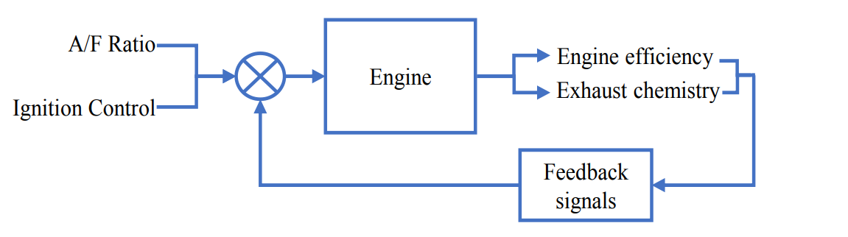

**Fig 2.1 Closed-loop control concept**

**2.2 Mathematical background**

1. Speed Density Model

The amount of air entering in engine’s cylinder is determined in order to schedule proper base fuel to the injector. Speed density model is used which calibrate the engine as an air pump and in this case, intake density and pump efficiency are known as a function of speed and load. Then, air mass along with relative air change (load) is calculated to get a basic fuel pulse width. Intake air density is calculated by using ideal gas law(1),

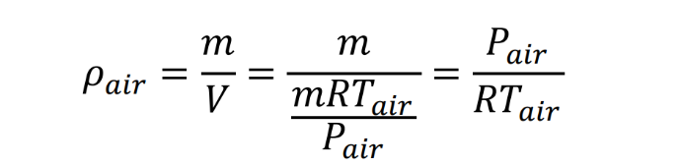 (1)

Where Pair is the intake manifold pressure, Tair is the intake manifold temperature and ܴ is the ideal gas constant. The intake air volume (Vair) is a function of volumetric efficiency and calculated for each cycle by using (2):



(2)

Where tetha is the volumetric efficiency, Vcyl is the cylinder volume and N is the engine rpms. Equation (3) gives the mass of air entering in the engine and is used to calculate the load on each interval.

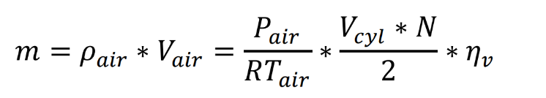

(3)

Where m is the amount of air in each cylinder. It can be observed that theta is a function of intake air pressure and engine load and is selected from the internal “map” shown in the Fig. 2. In order to calculate relative air change (engine load), the air mass is divided by nominal cylinder air mass which is the mass of cylinder when piston is at the bottom dead center (BDC), at standard air temperature and pressure.

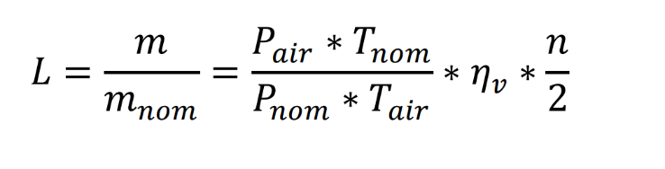

(4)

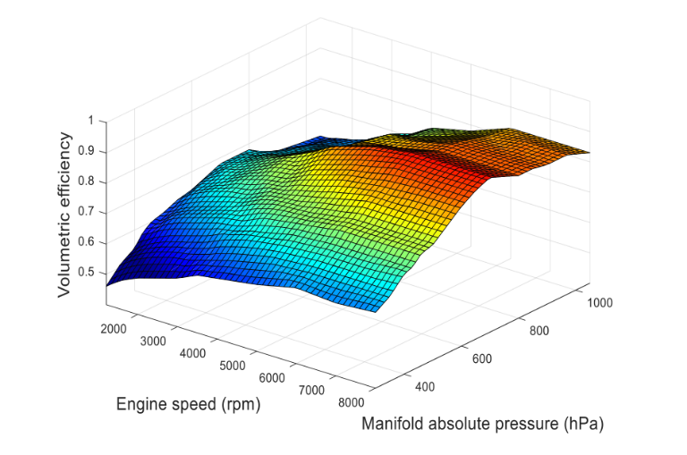Where L is the engine load, mnom the nominal cylinder is mass, Pnom is the nominal pressure, n is the no. of revolutions and Tnom is the nominal temperature at standard conditions.

**Fig 2.2 3D map of volumetric efficiency w.r.t. intake manifold pressure and engine speed**

1. Fuel Injection Pulse Width

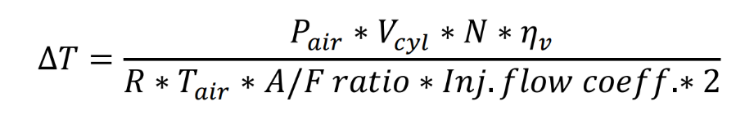The fuel pulse width is calculated by using that mass of air as per following equation (5):

(5)

Where ∆T is the basic fuel pulse width, A/F is the ratio of air with fuel and Inj.flow coefficient is a correction factor used for the variation of temperature from nominal. The final pulse width is composed with basic fuel pulse width along with different correction factors and is calculated by using (6):

 (6)

Where, ∆Tf is the final pulse width, fgf is the global fuel enrichment factor, fst is start correction factor, fas is after start correction factor, fwp is warm-up correction factor, fcl is closed-loop correction factor and fbv is battery voltage correction factor.

**CHAPTER 3**

**METHODOLOGY**

**3.1 Schematic Setup**

Fig. 3 shows the schematic representation of closed-loop EFI integrated on motorbike engine and Fig. 4 shows its experimental setup. Table I shows the specifications of the engine, which is used for this experiment. It is a typically a low powered motorbike in South East Asia. The EFI system is applied in place of carburetor and a program for basic calibrations of A/F mixture is burned in the electronic control unit (ECU). A logic element is set in ECU to process different sensors output voltages and its basic calibrations are modified by using resulting signals. It, in the end, maintains A/F ratio operating point, which reduces fuel consumption and also controls vehicle emissions. Both fuel injection quantity and ignition timing are controlled and synchronized by using this particular system.

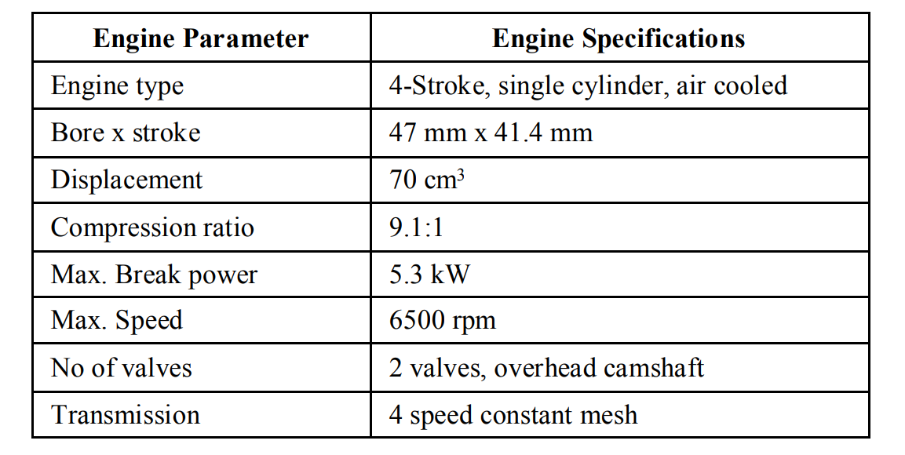

**Table 1 Specifications of Motorbike Engine**

FUEL DELIVERY SYSTEM - The fuel delivery system includes an electronic driven turbine style fuel pump, a fuel filter, single cylinder fuel injector, a vacuum operated fuel pressure regulator to maintain the pressure and supply and return lines. The fuel which is to be delivered to the injector must be at nominal pressure of 300 kPa (43.5 psi gauge).

The maximum flow rate for one-cylinder engine is 25 L/h (5.5 gal/h); excess fuel is returned to the tank. The pump is an inline turbine style electric fuel pump that consists of an electric motor that sucks the fuel from the tank at higher speed, typically up to 7,000 rpm. Variation of fuel pressure from 3 bar and flow rate of 25 L/h will adversely affect the performance of EFI system.

The fuel is sprayed by using single-hole fuel injector that consists of solenoid-actuated needle valve. It makes the fine spray particles in order to maintain uniform distribution of fuel in air stream. The quantity of fuel, which is to be delivered at certain conditions, depending upon the time for which injector is open (pulse width) and it operates for 1000 times at any linear pulse. The characteristics of the fuel injector are listed in Table II.

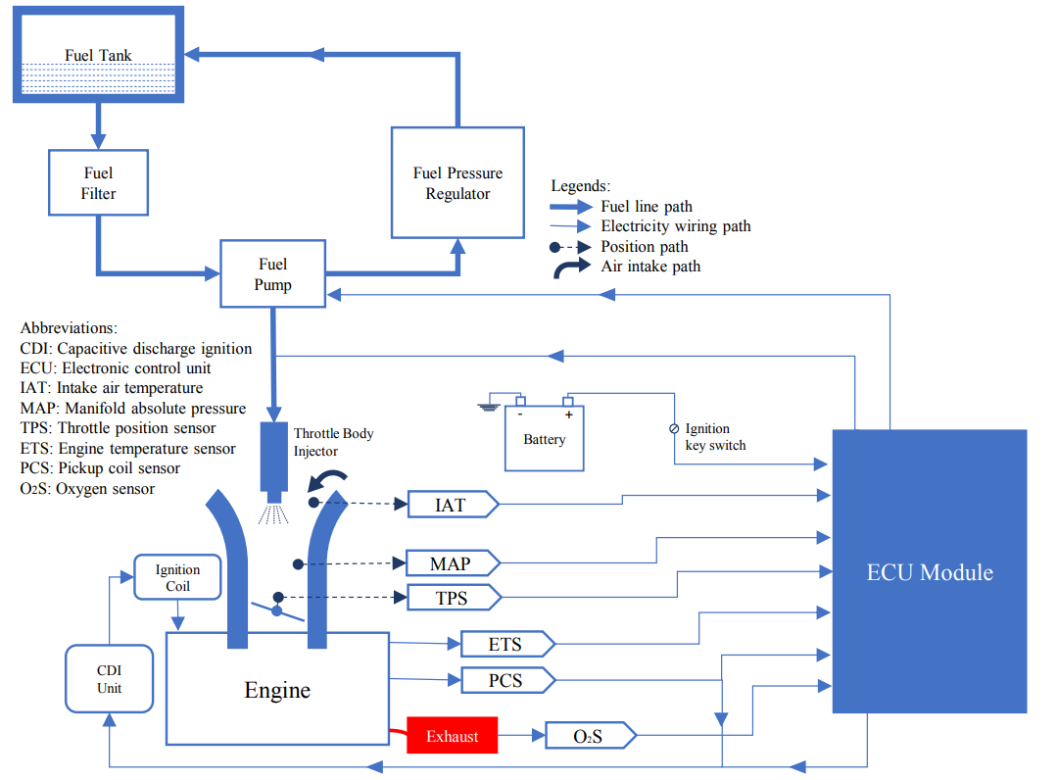

**Fig 3.1: EFI system schematics integrated to motorbike engine**

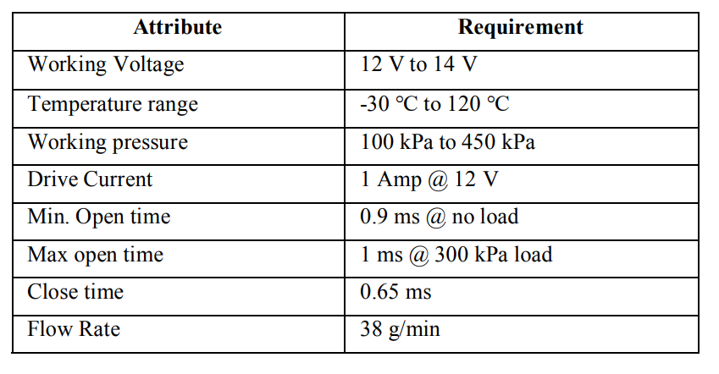

**Table 2: Fuel Injector Specifications**

**3.2 Air Induction System**

The air induction system includes the throttle body, which is made of cast iron, and enclose throttle position sensor (TPS), fuel injector and manifold absolute pressure (MAP) sensor in small hosepipes. The outlet of the throttle body is modified by contracting its outlet bore from 28 mm to 20 mm in order to overcome the excess bore size according to engine intake diameter. The size of fuel injector seat is also enlarged by using boring operation from 8 mm to 12 mm, so that the injector can easily adjusted.

Intake Manifold of 104 mm length and with the intake diameter of 20 mm is installed adjacent to the outlet of throttle body. INPUT SIGNAL COMPONENTS – The input signal components include various sensors that give input to the ECU to judge the working condition of engine for A/F ratio control. The MAP sensor is used to monitor the engine load and dynamic manifold pressure through vacuum created by the suction of the engine. It is a variable resistor assembly with voltage signals variation from 0.5 V at 20 kPa to 4.9 V at 103 kPa. The conversion of analog signals from MAP sensor into pressure is a linear change by using (7):

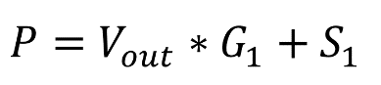

(7)

Where P the manifold pressure (hPa), Vout is the MAP voltage, G1 is the slope and S1 is the offset value. It draws current less than 10 mA during working conditions with response time of less than 2 ms.

The two temperature sensors used are thermistors having negative temperature coefficient (NTC). NTC 1 is the engine temperature sensor (ETS) made of semiconductor material germanium with a hole of 6.5 mm and is fitted on the cylinder head of the engine where the heat is mostly reflecting the engine real temperature. On the other hand, NTC 2 is the intake air temperature (IAT) sensor installed on airstream flow path, and is used to measure the air temperature. Since information from NTC 2 is used throughout the entire process by ECU to calculate the correct airflow information, NTC 1 is the key component in achieving the wholesale enrichment that is needed to overcome “cold-start” problem. Resistance temperature (R-T) curve for NTC 1 and NTC 2 is shown in the Fig. 5. A very low voltage of about 0.5 V is detected from NTC 1 during cold-start simply influence the ECU to increase the pulse timing. This actually “doubled-up” the firing of the injector as long as the starter is cranking. This decision is based on NTC 1 input and cranking rpm for ECU, thus excluding the use of the choke valve during cold start.

TPS monitors the position of butterfly valve in throttle body. The valve position is detected in order to monitor the air entering the engine. Its voltage varies linearly from 0.45 V to 4.5 V w.r.t. throttle angle and maximum installation torque of 49.03 mN.m. If the driver suddenly accelerates, the ECU will consider this as 4.5 V signal and increase the fuel injector pulse-width to compensate for the amount of air entering.

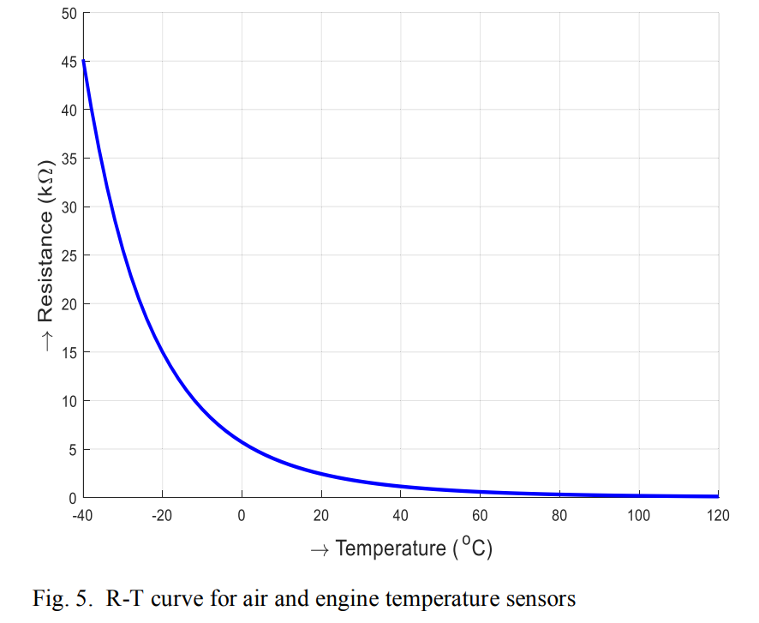

**Fig 3.2: R-T curve for air and engine temperature sensors**

For precise control on ignition timing, the crank angle should be accurately detection. The system detects the crank angle directly from the crank rather than from other half speed shafts, which can introduce errors due to backlash. The crankshaft position sensor (CPS) is used for this purpose. It is a magnetic pickup coil sensor that is attached to the pickup signal coil of the spark plug, thus providing the speed information and the position of the crankshaft for spark plug ignition. The feedback signal is a very important parameter to control the amount of fuel as well as emissions and only possible in closed-loop mode. Oxygen (lambda) sensor (O2S) provides information about the presence of oxygen in the exhaust gases. The O2S used is made of a hollow cylindrical tube of stabilized zirconium dioxide which acts as a solid electrode and has unique characteristics, shown in Fig. 6, as its potential varies abruptly from 900 mV at a rich A/F ratio (λ < 1) to 100 mV at a lean A/F ratio (λ > 1) according to Nernst equation (8).



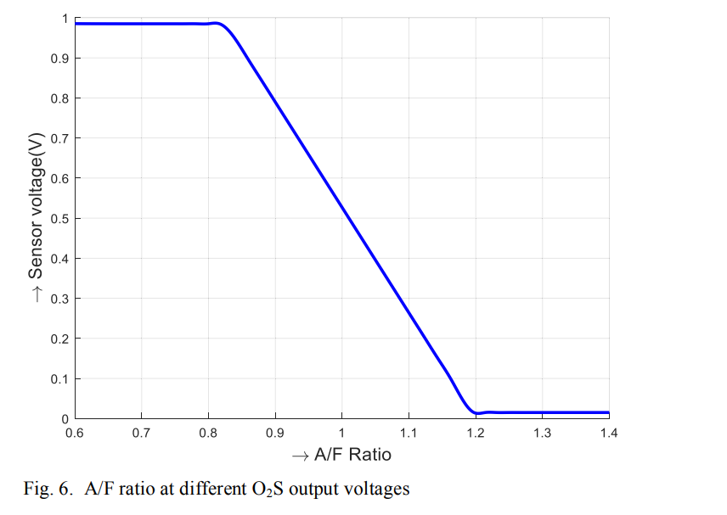(8)

**Fig 3.3: A/F ratio at different O2S output voltages**

Approximately 20 to 30 seconds are required for the oxygen sensor to be heated at threshold temperature of 300 ℃ before its operation. It will not give feedback until the threshold is reached. So during engine start-up and warm-up operation, the fuel delivery system works in open-loop mode and operates by a selected engine start-up and warm-up fuel factors and falls on a set of internal “maps” until the required operating temperature reached.

**3.3** **Process Control and Calibration Components**

The process control and calibration unit consist of ECU, portable connection socket and harness for communication. ECU, which is used, is actually a 20-pin microprocessor that includes application specific integrated circuits or ASIC chips and read vehicle parameters from different sensing devices mounted on the engine. It is integrated with the self-learning and return type fuel injection system modes that calculate the amount of fuel and ignition timing for an internal combustion engine to keep running. As shown in Fig. 7, information is provided through various input sensors measuring data acquisition to judges the prevailing engine condition and then performs the optimization and controls the tasks according to the operating condition of the engine. It consumes less than 60 mA of current and 9 V to 16 V DC voltage supply.

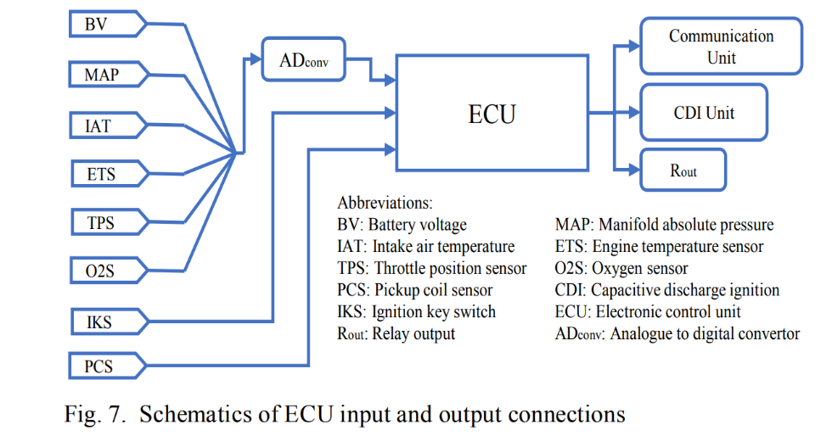

**Fig 3.4 Schematics of ECU input and output connections**

**3.4 EFI performance parameters**

After the assembly of the E.F.I on bike engine, the next step is to monitor its performance. For the purpose, all the performance parameters are set on a soft console, which includes engine specifications, fuel and altitude factors, sensors calibration parameters, idle condition and wide open throttle (WOT) calibration, and many other parameters for efficient and smooth engine operation.

Overall fuel enrichment factor depends on three main factors: start factor (fst), after-start factor (fas) and warm-up factor (fwp) and are used in (6) to calculate accurate pulse width. The basic fuel flow depends on the global fuel enrichment factor which is applicable in many vehicle operating conditions such as start, warm-up, and transient and steady-state conditions. The fuel enrichment factor in our case is 1.2 for before start condition and 1 for all other operating conditions.

Fst majorly depends on the engine temperature because during start of the engine, the inlet air temperature is low, so more air per unit volume enters the engine. If the fuel is supplied according to stoichiometric A/F ratio, the mixture will become lean which at the end causes vibrations, unstable idle conditions and engine flameout. Mixture, therefore, should be dense for a while during the engine start. The start-up factor gradually reduces with the increase in engine temperature. This factor does not self-tune by the ECU because self-tuning depends on engine temperature and only operates after warm-up condition. Therefore, it is calibration by a hit and trial method that will be terminated when engine reaches up to 1020 rpm.

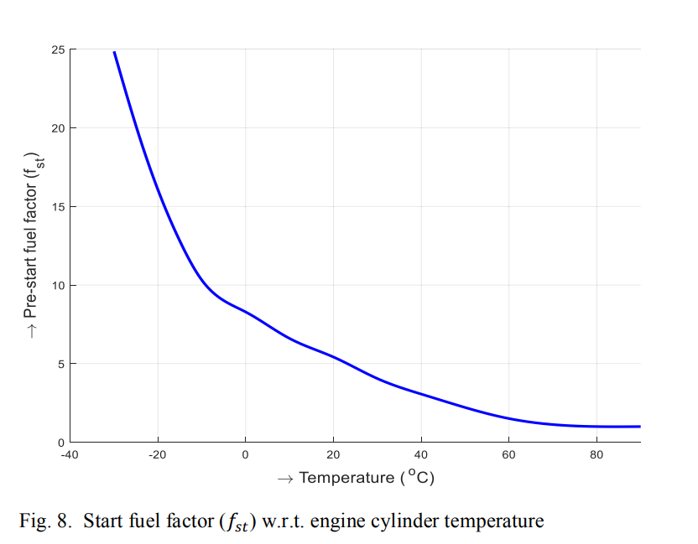

**Fig 3.5 Start fuel factor (fst) w.r.t. engine cylinder temperature**

The idle speed is control by the idle fuel, which depends upon the idle pulse width limit (2 ms). This speed is adjusted by taking account of O2S output voltage that shows the lambda value for the specific conditions. It is further controlled by mechanical idle airscrew and is set in a position by taking account of rpm during warm-up, which is considerably higher than any other conditions. Next to reduce the rpm after full warm-up, the main strategy used is to retard the idle spark advance angle, that also reduces the torque and undercharging condition, and hence reduce the emissions. The basic ignition angle setting is implemented based on closed-loop mode. it is actually the spark advance that can run the engine at maximum torque depending on engine speed and load without causing knock. Each value contains 2- 5% buffer to reserve to protect the engine from damage.

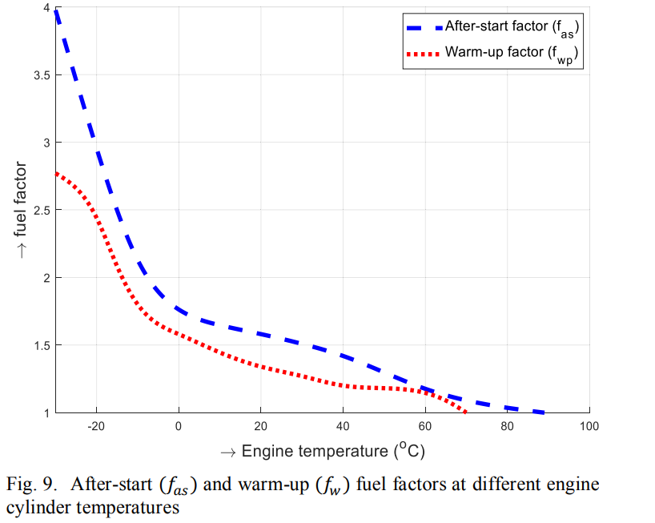

**Fig 3.6 After-start (fas) and warm-up (fw) fuel factors at different engine cylinder temperatures**

As some residual gases are trapped inside the combustion chamber at the end of exhaust stroke, fresh air and corresponding mass of air change (load) is calculated through speed density method for exact control on pulse width. Final fuel pulse width is further accurate by using the desired lambda factor which is basically a dividing factor on the base fuel mapping and takes the vicinity of stoichiometric AFR.

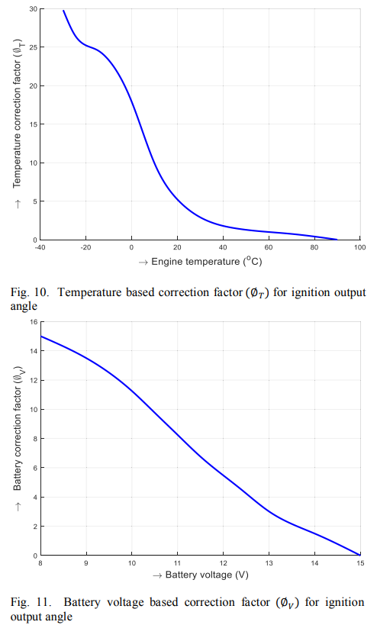

**Fig 3.7 Temperature based correction factor for ignition output angle**



**Fig 3.8 Battery voltage based correction factor for ignition output angle**

**3.5 EFI Performance Testing Procedure**

After input all the parameters for EFI system, next step was to test the performance of EFI installed engine and then compared the fuel consumption of EFI installed engine with carbureted engine. Initially a fuel beaker with 700 ml gasoline fuel was attached with the fuel intake supply line, which followed the fuel pump, and the return line from the fuel regulator was attached at the upper pipe of the beaker for the excess fuel to return to the beaker. The performance was monitored at idle condition plus in a set of 4 different test points. The engine performance parameters from different sensors were noted down after covering the distance of 4 km in different 4 rpm conditions. Afterwards, the fuel consumption and the mileage of the EFI with the carburetor were compared for low powered motorbike engine.

Finally, one liter of fuel was taken to check the mileage of the bike for both carbureted engine and EFI engine system. The operating conditions were same as for the previous shortrange experiments. The whole experiment of mileage included sudden acceleration and decelerations with a varying range from 25 km/h to 55 km/h, brakes, WOT condition and curing conditions for EFI installed bike and every aspect was same as those were for the carburetor test. The main objective was to observe the mileage of motorbike per liter fuel.

**CHAPTER 4**

**RESULT ANALYSIS**

**4.1 RESULTS AND DISCUSSIONS**

The experimental observations of fuel consumption for closed-loop EFI system and for carbureted system at different speeds are shown in Fig. 13. Both systems follow the same trend; decreasing fuel consumption with the increased speed up to around 40 km/h and increase fuel consumption thereafter. The EFI system shows an average of 13% better fuel economy over most of the speed range than carbureted engine.

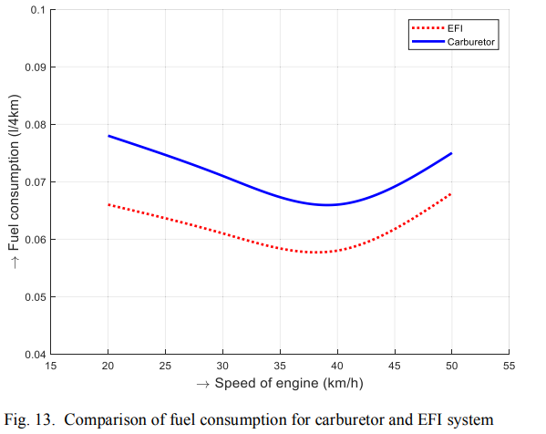

**Fig 4.1 Comparison of fuel consumption for carburetor and EFI system**

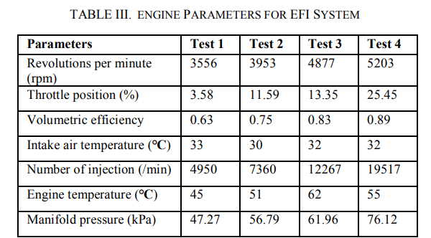

**Table 3 Engine Parameters For EFI System**

By using 1 liter of fuel with a carburetor assembly, a mileage of 55km has observed. With same engine condition and load for EFI system, a mileage of approximately 64km has observed. This gives an increase of 9 km per liter more mileage that is equal to the 16.36% increase in fuel efficiency for a specified baseline vehicle.

This system also eliminates the use of a choke valve. This is actually done by using NTC 1 that gives a very low voltage reading (less than 0.5 V) to ECU during cold start. This actually increases the start fuel factor and pulse width become double to inject more quantity of fuel, which is a manual process in carburetor.

Additional EFI system provides flexibility to control the A/F ratio as function of engine power demand, while utilizing the ability to enrich the mixture during sudden acceleration (rapid throttle), and cut down the supply of fuel during engine breaking, thereby improving the drivability and fuel consumption of the motorbike further. In case of carburetor, system does not response spontaneously during sudden change of requirements such as sudden acceleration and deceleration and with altitude changes etc. that results in improper fuel supply, cause misfiring and hence affecting performance and drivability. Additionally it causes more engine knock and emissions.

**CHAPTER 5**

**CONCLUSIONS & FUTURE SCOPE OF WORK**

**5.1 Conclusions**

In this paper, a standard mechanical carburetor was replaced with the self-learning E.F.I. system for four-stroke small powered motorbike engine to investigate fuel consumption and drivability. This had involved the installation of air induction system, fuel supply system and input signal system. A proper interface had developed between ECU of EFI and these systems by using closed-loop feedback approach. Results had shown that EFI system provided average fuel saving of 13% for most of the speed range. By one-liter investigation method, a fuel efficiency had roughly calculated around 16.4% on road test. It had further increased the mileage of approximately 9 km per liter. Reason for the improvement in fuel consumption had achieved by determination of optimum fuel injection quantity by altitude compensation factor, pre-start, cold start and warm-up compensation factors, lambda factor and by optimization of different maps for the engine according to its speeds and loads. Further, EFI has minimized the power sacrifice during sudden acceleration and deceleration, sudden braking and WOT position as a function of engine power demand and system operates at nearly stoichiometric A/F ratio, hence improves drivability and performance.

**5.2 Future scope of work**

* We can further improve the performance by using Alpha N method.

# References

|  |  |
| --- | --- |
| [1] | M. F. Hushim, . J. A. Alimin, H. Selamat and . M. T. Muslim, "PFI System for retrofitting small 4-stroke gasoline engines," International Journal of Environmental Science and Development, vol. 4, no. 4, pp. 375-378, 2013 |
| [2] | M. F. Hushim, A. J. Alimin, L. A. Rashid and M. F. Chamari, "Influence of fuel injector position of port-fuel injection retrofit-kit to the performances of small gasoline engine," AIP Conference Proceedings, vol. 1440, pp. 418-424, 2012 |
| [3] | M. F. Hushim, J. A. Alimin and M. F. Mansor, "Effect of Intake Manifold Angle of Port-fuel Injection Retrofit-kit to the Performances of an S.I. Engine," in Applied Mechanics and Materials, 2012. |
| [4] | M. T. Muslim, H. Selamat, A. J. Alimin, N. M. Rohi and . M. F. Hushim, "A review on retrofit fuel injection technology for small carburetted motorcycle engines towards lower fuel consumption and cleaner exhaust emission," Renewable and Sustainable Energy Reviews, vol. 35, pp. 279-284, July 2014. |
| [5] | T. S. Lai and H. Gitano-briggs, "Development of a Small Motorcycle EFI Retrofit System," 2009. |